RV COLLEGE OF ENGINEERING®, BENGALURU-560059

(Autonomous Institution Affiliated to VTU, Belagavi)

**DEPARTMENT OF COMPUTER SCIENCE AND ENGINEERING**



**AI-Powered Product Management and Analytics Platform for Smarter Business Decisions**

##### Mini - Project Report

###### *Submitted by*

**KUSHAL R U 1RV22CS093**

**KISHOR PATIL 1RV22CS088**

**KIRAN V 1RV22CS086**

***in partial fulfillment for the requirement of 5th Semester***

***Database Management Systems Laboratory Mini Project (CD252IA)***

**Under the Guidance of**

**Dr. Pratiba D, Associate Professor**

**COMPUTER SCIENCE AND ENGINEERING**

**RV COLLEGE OF ENGINEERING**

**Academic Year 2024- 2025**

**RV COLLEGE OF ENGINEERING®, BENGALURU - 560059**

**(Autonomous Institution Affiliated to VTU, Belagavi)**

**DEPARTMENT OF COMPUTER SCIENCE AND ENGINEERING**



**CERTIFICATE**

Certified that the project work titled **‘AI-POWERED PRODUCT MANAGEMENT AND ANALYTICS PLATFORM FOR SMARTER BUSINESS DECISION’** is carried out by **KUSHAL R U (1RV22CS093), KISHOR PATIL (1RV22CS088) and KIRAN V (1RV22CS086)** who are bona-fide students of RV College of Engineering®, Bengaluru, in partial fulfillment of the curriculum requirement of 5th Semester Database Management System Laboratory Mini Project during the academic year **2024-2025**. It is certified that all corrections/suggestions indicated for the internal Assessment have been incorporated in the report deposited in the departmental library. The report has been approved as it satisfies the academic requirements in all respect laboratory mini-project work prescribed by the institution.

**Signature of Faculty In-charge Head of the Department**

**Dr. Pratiba D Dr. Shanta Rangaswamy**

**Dept of CSE, RVCE Dept. of CSE, RVCE**

**External Examination**

**Name of Examiners Signature with date**

**1**

**2**

**ACKNOWLEDGEMENT**

Any achievement, be it scholastic or otherwise does not depend solely on the individual efforts but on the guidance, encouragement and cooperation of intellectuals, elders and friends. A number of personalities, in their own capacities have helped me in carrying out this project work. I would like to take this opportunity to thank them all.

We deeply express our sincere gratitude to my guide **Dr. Pratiba D, Associate Professor,** Department of CSE, RVCE, Bengaluru,for her able guidance, regular source of encouragement and assistance throughout this project.

We would also like to thank **Dr. Shanta Rangaswamy, Head of Department**, Computer Science & Engineering, R.V.C.E, Bengaluru, for his valuable suggestions and expert advice.

Moreover, I would like to thank **Dr. Subramanya. K. N**, **Principal**, R.V.C.E, Bengaluru, for his support towards completing the project work.

We thank our Parents, and all the Faculty members of Department of Computer Science & Engineering for their constant support and encouragement.

Last, but not the least, I would like to thank my peers and friends who provided me with valuable suggestions to improve my project.

**Abstract**

In today’s fast-paced and data-driven business landscape, companies must leverage advanced technologies to stay competitive. The **AI-Powered Product Management and Analytics Platform for Smarter Business Decisions** is designed to revolutionize how businesses manage products, optimize strategies, and make informed decisions. By harnessing the capabilities of artificial intelligence and data analytics, this platform processes vast amounts of information from multiple sources, including **market trends, customer feedback, and historical sales data**.

At its core, the platform employs cutting-edge **machine learning algorithms** to deliver **predictive analytics, real-time insights, and intelligent recommendations**. Businesses can utilize these capabilities for **demand forecasting, product performance evaluation, customer sentiment analysis, and the identification of emerging market opportunities**. The integration of **interactive data visualization tools** ensures that complex analytics are presented in an intuitive and user-friendly manner, empowering decision-makers at all levels to extract meaningful insights with ease.

By bridging the gap between raw data and strategic action, this platform enables organizations to **anticipate customer needs, mitigate risks, enhance operational efficiency, and optimize inventory management**. Its AI-driven approach fosters a proactive decision-making culture, equipping businesses with the agility to adapt to evolving market dynamics.

The project highlights the transformative role of AI-powered analytics in modern business environments, demonstrating how intelligent data utilization can drive **growth, profitability, and long-term success**. By providing businesses with actionable intelligence and automation, this platform paves the way for smarter, data-driven decision-making in an increasingly competitive and complex marketplace.

**Table of Contents**

**Acknowledgement 3**

**Abstract 4**

**Table of Contents 5**

**List of Figures 6**

|  |  |
| --- | --- |
| Contents | Page Number |
| 1. Introduction | 7 |
| 1. Software Requirement Specification | 8-10 |
| 1. ER diagram | 11 |
| 1. Detailed Design | 12-13 |
| 1. Relational Schema and Normalization | 14-16 |
| 1. NoSQL | 17 |
| 1. Conclusion and Future Enhancement | 18 |
| 1. Appendix | 19-25 |

**List of Figures**

|  |  |  |
| --- | --- | --- |
| Figure No | Figure Name | Page No |
| 1 | ER Diagram | 11 |
| 2 | DFD Level-0 | 14 |
| 3 | DDF Level-1 | 15 |
| 4 | Schema Diagram | 17 |
| 5 | Normalization | 18 |
| 6 | Home Page | 21 |
| 7 | Best Crypto | 22 |
| 8 | Sign In Page | 22 |
| 9 | Sign Up Page | 23 |
| 10 | Explore Page | 23 |
| 11 | Portfolio Page | 24 |
| 12 | Transactions Page | 24 |
| 13 | Discussion Page | 25 |
| 14 | Chatbot | 25 |
| 15 | Candlestick graph | 26 |
| 16 | News Sentiment Analysis | 26 |
| 17 | Portfolio Optimizer | 27 |
| 18 | Results of Optimizer | 27 |

**Chapter 1**

**Introduction**

In today’s rapidly evolving digital marketplace, businesses must efficiently manage their products while providing a seamless and engaging shopping experience for customers. The increasing complexity of product management, dynamic consumer behavior, and growing competition necessitate **data-driven decision-making** powered by AI and advanced analytics. AI-powered analytics and intelligent automation have transformed how businesses handle **product lifecycles, customer interactions, and market decisions**, enabling them to operate more efficiently while meeting consumer expectations.

This project introduces the **AI-Powered Product Management and Analytics Platform**, a **comprehensive e-commerce and analytics solution** designed to benefit both **business administrators and customers**. **Admins** have the capability to **upload, manage, and track product performance**, gaining **real-time insights** into **sales trends, customer feedback, and demand forecasting**. The platform equips administrators with **AI-driven analytics** to optimize product offerings, identify consumer preferences, and enhance business strategies. Meanwhile, **customers** can seamlessly **browse, purchase products, and provide feedback**, ensuring a highly optimized and user-friendly shopping experience.

By leveraging **machine learning algorithms and advanced data analytics**, the platform helps businesses **identify market trends, optimize inventory, and improve decision-making**. The **AI-driven personalization** further enhances the user experience by tailoring recommendations based on customer behavior, purchase history, and preferences. This combination of intelligent automation and predictive analytics makes the platform a **powerful tool for modern businesses**, ensuring operational efficiency, customer satisfaction, and **long-term market success**.

**Chapter 2**

**Software Requirement specification**

A software requirements specification (SRS) is a description of a software system to be developed. The software requirements specification lays out functional and non-functional requirements, and it may include a set of [use cases](https://en.wikipedia.org/wiki/Use_case) that describe user interactions that the software must provide to the user for perfect interaction.

Software requirements specification establishes the basis for an agreement between customers and contractors or suppliers on how the software product should function (in a market-driven project, these roles may be played by the marketing and development divisions). Software requirements specification is a rigorous assessment of requirements before the more specific system design stages, and its goal is to reduce later redesign. It should also provide a realistic basis for estimating product costs, risks, and schedules.

**2.1 Hardware Requirements**

The platform requires the following minimum and recommended hardware specifications to ensure smooth performance and reliability:

**Minimum Requirements:**

* **Processor:** 64-bit x86 CPU
* **Memory (RAM):** 6 GB
* **Storage:** 5 GB of free disk space

**2.2 Software Requirements**

**Operating System:**

* **Linux:** Supports various distributions such as Ubuntu, CentOS, and Debian.
* **Windows:** Compatible with Windows 10/11 and Windows Server versions 2016, 2019, and 2022.

**Frontend Development:**

* **React.js** (Version 18.2.0 or later) – Utilized for crafting a dynamic and interactive user interface.
* **HTML5, CSS3, and JavaScript,ReactJS** – Essential for structuring, designing, and enhancing the responsiveness of the web application.

**Backend** **Development**:

* **Node.js** (Version 18.16.0 or later) – Used for handling server-side operations and business logic.
* **Express.js** (Version 4.18.2 or later) – Facilitates the creation of RESTful APIs to enable seamless communication between the frontend and backend.

**Database Management:**

* **MySQL** (Version 8.0 or later) – Employed for managing structured data, including user accounts, product information, and transaction records.
* **MongoDB** (Version 6.0 or later) – Used for handling unstructured data such as system logs and metadata storage.

**Additional Tools:**

* **Postman** (Version 10.3.0 or later) – A tool for testing and debugging API endpoints.

**Development Environment:**

* **Visual Studio Code** (Version 1.81.1 or later) – A widely used integrated development environment for coding, debugging, and version control.
* **Git** (Version 2.42.0 or later) – Enables version control and collaborative development.
* **GitHub** – Used to store, manage, and track changes in the project’s source code.

**2.3 Functional Requirements**

**1. Sales Analysis Module**

**Input:**

* Product sales data, and customer purchase history.

**Process:**

* Analyze real-time sales performance using AI-powered analytics.
* Generate reports with data visualizations for better decision-making.

**Output:**

* Sales performance insights displayed in interactive dashboards.
* Automated reports highlighting revenue trends and product demand.
* Actionable recommendations for pricing and inventory management.

**2. Review Analysis Module**

**Input:**

* Customer feedback, ratings, and product reviews.

**Process:**

* Use AI-based sentiment analysis to classify reviews as positive, neutral, or negative.
* Extract key themes and trends from customer feedback.
* Provide suggestions for improving product quality and user experience.

**Output:**

* Detailed sentiment analysis reports on customer reviews.
* Highlighted areas for product improvements based on feedback trends.

**3. Sales Demand Analysis Module**

**Input:**

* Historical sales data, seasonal trends, and customer demand patterns.

**Process:**

* Apply machine learning models to forecast future sales trends.
* Analyze demand fluctuations based on past sales performance.
* Provide inventory recommendations to prevent overstocking or shortages.

**Output:**

* Predicted sales trends displayed in graphical reports.
* AI-driven insights to optimize stock levels and maximize profitability.
* Forecasting reports to support strategic business planning.

**4. Payment Integration Module**

**Input:**

* Customer purchase details, product selections, and payment preferences.

**Process:**

* Securely process payments through an integrated payment gateway.
* Validate transactions and ensure encrypted payment data storage.
* Confirm payment completion before order fulfillment.

**Output:**

* Order confirmation and payment receipts for customers.
* Secure transaction logs for financial tracking.
* Seamless payment experience for a smooth checkout process.

**2.3 User Roles and Responsibilities**

**1. Administrator**

**Responsibilities:**

* Manage user accounts, system configurations, and access controls.
* Oversee data synchronization and ensure platform stability.
* Monitor overall platform performance and resolve system issues.

**2. Customer Support**

**Responsibilities:**

* Track customer feedback and address concerns.
* Manage issue resolution and product improvement strategies.
* Provide support for order-related queries and service requests.

**Chapter 3**

**Entity Relationship Diagram**

An Entity Relationship (ER) Diagram is a visual representation similar to a flowchart, depicting the relationships between "entities" like people, objects, or concepts within a system. ER Diagrams are primarily utilized in designing or troubleshooting relational databases across various domains such as software engineering, business information systems, education, and research. Commonly referred to as ERDs or ER Models, these diagrams employ a set of symbols, including rectangles, diamonds, ovals, and connecting lines, to illustrate the connections between entities, relationships, and their attributes. They follow a structured format resembling grammar, with entities represented as nouns and relationships as verbs.

**1. Entities and Attributes**

**Product**

* Represents the core entity of the system, capturing details about the products being managed.
* Attributes:
  + Product_id: Unique identifier for each product.
  + Name: Name of the product.
  + Description: Detailed description of the product.
  + Price: Cost of the product.
  + Quantity: Stock availability of the product.
  + Image_url: Link to the product image.
  + Created_at: Timestamp when the product was created.
  + Created_by: User who created the product entry.

**Cart**

1. Represents the shopping cart for users.
2. Attributes:
   * Cart_id: Unique identifier for each cart.
   * User_id: Identifier for the user who owns the cart.
   * Created_at: Timestamp when the cart was created.

**Cart_items**

* Represents the items within a shopping cart.
* Attributes:
* Cart_items_id: Unique identifier for each cart item.
* Cart_id: Identifier for the cart.
* Product_id: Identifier for the product.
* Quantity: Quantity of the product in the cart.

**Order_items**

* Represents the items within an order.
* Attributes:
  + Order_items_id: Unique identifier for each order item.
  + Order_id: Identifier for the order.
  + Product_id: Identifier for the product.
  + Quantity: Quantity of the product in the order.
  + Price: Price of the product at the time of the order.

**Reviews**

* Represents customer feedback associated with products.
* Attributes:
* Review_id: Unique identifier for each review.
* Product_id: Identifier for the product.
* User_id: Identifier for the user who provided the review.
* Rating: Numeric rating provided by customers.
* Feedback: Detailed feedback from customers.
* Created_at: Timestamp when the review was created.

**2.Relationships**

* **Product Receives Feedback**
  + Type: M:N
  + A product can receive multiple reviews, and a review is linked to a specific product.
* **Cart Has Cart_items**
  + Type: 1:M
  + A cart can contain multiple cart items, and each cart item is linked to a specific cart.
* **Product Is Included In Cart_items**
  + Type: 1:M
  + A product can be included in multiple cart items, and each cart item is linked to a specific product.
* **Product Is Included In Order_items**
* Type: 1:M
* A product can be included in multiple order items, and each order item is linked to a specific product.

**3. Attributes**

* **Product**:Product_id, Name, Description, Price, Quantity, Image_url, Created_at, Created_by.
* **Cart**: Cart_id, User_id, Created_at.
* **Cart_items**: Cart_items_id, Cart_id, Product_id, Quantity.
* **Order_items**: Order_items_id, Order_id, Product_id, Quantity, Price.
* **Reviews**: Review_id, Product_id, User_id, Rating, Feedback, Created_at.

**4.Flow of Information**

**Product Management**

Details of products, including attributes like price, description, and quantity, are stored and maintained within the system.

**Customer Feedback Analysis**

Reviews submitted by customers are linked to specific products and analyzed to evaluate customer satisfaction and sentiment.

**Sales Tracking**

Sales data, including order details and revenue, is captured to assess product performance and profitability.

**Performance Evaluation**

Product performance is measured using defined metrics and stored for analysis to improve decision-making.

**Centralized Database**

The database integrates all entities, relationships, and attributes, ensuring secure and efficient storage for real-time analysis and reporting.

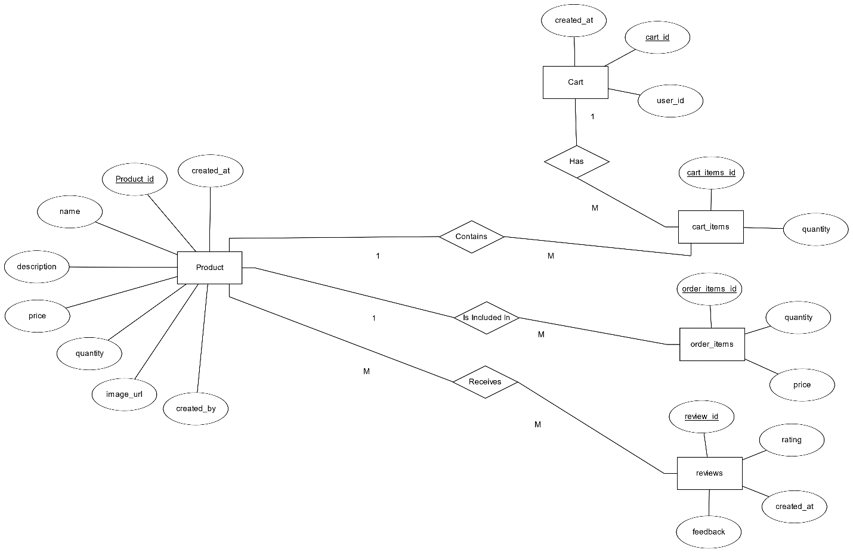

Figure 1 ER Diagram

**Chapter 4**

**Detailed Design**

A Data Flow Diagram (DFD) is a conventional visual tool that illustrates the flow of information within a system, providing a clear depiction of system requirements. It can encompass manual, automated, or mixed processes, showcasing how data enters and exits the system, undergoes modifications, and where it's stored. The primary aim of a DFD is to delineate the scope and boundaries of a system comprehensively. DFDs are hierarchical, with each layer delving deeper into the system or data. Typically, these layers are represented as Levels 0 through 2, each progressively revealing more intricate details about the system's components and operations.

DFDs consist of four primary components: processes (circles or rectangles), data stores (open-ended rectangles), external entities (squares), and data flows (arrows). Processes represent functions that transform data, while external entities interact with the system by providing or receiving information. Data stores represent places where information is stored temporarily or permanently, and data flows illustrate the movement of data between these components. By clearly defining these elements, DFDs help in identifying bottlenecks, redundancies, and inefficiencies within a system.

One of the key benefits of DFDs is their hierarchical nature, allowing systems to be broken down into different levels of complexity. Level 0 DFDs (also called Context Diagrams) provide a high-level view of the entire system, showing only the main process, external entities, and data flows. Level 1 and Level 2 DFDs progressively decompose the system into more detailed subprocesses, offering a deeper understanding of how individual components interact. This structured approach makes DFDs scalable and adaptable, enabling gradual refinement of system design.

**4.1 DFD Level 0**

A Data Flow Diagram (DFD) Level 0, also recognized as the fundamental system model or context diagram, portrays the entirety of software requirements within a single bubble. Input and output data are indicated by incoming and outgoing arrows. Subsequently, the system is broken down and depicted as a DFD with multiple bubbles. Each of these bubbles represents parts of the system, which are further decomposed and elaborated upon through more detailed DFDs as the analysis progresses.

1. **Entities**:
   1. **Customer**: Interacts with the Product Purchasing System for registration/login, placing orders, providing feedback, and completing payments.
   2. **Admin**: Oversees system operations by managing product data, analyzing sales data, and generating reports.
   3. **Payment Gateway**: Processes payment details from the system and confirms transactions.
2. **Data Flow**:
   1. **Customer → Product Purchasing System**: Sends data like registration/login details, product orders, payment information, and feedback.
   2. **Product Purchasing System → Customer**: Provides product details and payment confirmations.
   3. **Admin → Product Purchasing System**: Admin submits product management requests and analysis tasks.
   4. **Product Purchasing System → Admin**: Sends sales and report data for analysis.
   5. **Payment Gateway ↔ Product Purchasing System**: Exchanges payment details and transaction confirmations.

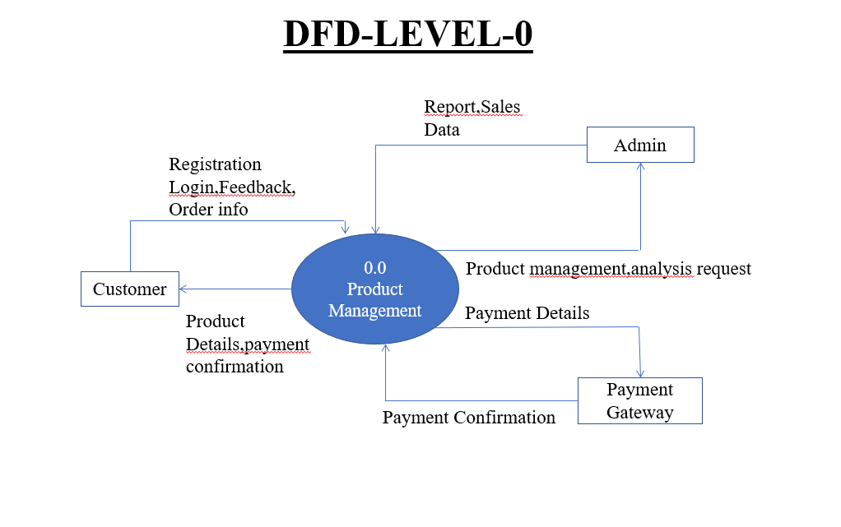

Figure 2 DFD level 0 of RVesting: Crypto A Portfolio Management System

The **DFD Level 0** (Context Diagram) provides a high-level overview of the **Product Purchasing System**, illustrating the interaction between key entities and data flows. The **Customer** engages with the system by registering, logging in, placing orders, making payments through the **Payment Gateway**, and submitting feedback. The **Admin** manages the system by adding and updating product information, analyzing sales data, and generating reports. Data flows seamlessly between these entities, with the **Customer** sending registration details, order requests, payment information, and feedback, while the system responds with product details and payment confirmations. The **Admin** interacts by submitting product management requests and receiving sales performance insights. Additionally, the **Payment Gateway** processes payment details and confirms transactions. This structured data flow ensures efficient order processing, seamless transactions, and data-driven decision-making for business optimization.

**4.2 DFD Level 1**

Level 1 of the Data Flow Diagram (DFD) provides a deeper level of detail, focusing more sharply on specific functions within the system or process. It breaks down the main functions highlighted in the Level 0 overview, providing explanations for each. At this level, the context diagram is decomposed into multiple bubbles or processes, emphasizing the main objectives of the system and breaking down the high-level processes outlined in the Level 0 DFD into subprocesses. In simpler terms, Level 1 DFD elaborates on the overall system's functions and breaks them down into more detailed subprocesses.

**1. Entities and Modules:**

* **User Management (0.1):**
  + Handles customer registration and login.
  + Maintains user-related information.
* **Feedback Management (0.2):**
  + Collects reviews and ratings from customers.
  + Stores and processes feedback for analysis.
* **Order Management (0.3):**
  + Processes orders placed by customers.
  + Updates stock information after order confirmation.
* **Payment Management (0.4):**
  + Manages payment details and sends requests to the Payment Gateway.
  + Confirms payment status for successful transactions.
* **Product Management (0.5):**
  + Admin creates, updates, or views product details.
  + Handles product stock updates after order placement.
* **Analysis Management (0.6):**
  + Processes sales and feedback data for generating reports.
  + Provides insights and analytics for the Admin.

**2. Flow of Information:**

* **Customer → User Management:**
  + Sends registration/login details, which are validated and stored.
* **Customer → Feedback Management:**
  + Provides reviews and ratings for purchased products.
* **Customer → Payment Management:**
  + Sends payment information, which is forwarded to the Payment Gateway for processing.
  + Receives payment confirmation upon successful transactions.
* **Customer → Order Management:**
  + Places order requests, which are processed, and stock details are updated.
* **Admin ↔ Product Management:**
  + Admin performs product updates, which are reflected in the system.
* **Admin ↔ Analysis Management:**
  + Admin requests reports, which are generated based on sales and feedback data stored in databases (MongoDB and MySQL).

**3. Databases:**

* **MongoDB:**
  + Stores user registration details and order details.
* **MySQL:**
  + Stores sales data and product information for report generation.

**4. Key Processes:**

* Feedback from customers is stored and analyzed for providing seuggestions for betterment of product.
* Orders are managed end-to-end, including stock updates and payment confirmations.
* 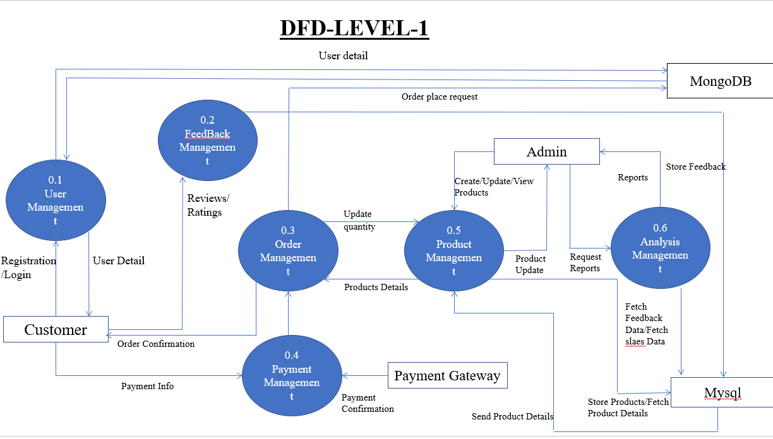Admin has a central role in managing products, overseeing reports, and ensuring system functionality.

The **DFD Level 1** further decomposes the **Product Purchasing System** into key functional modules, detailing how entities interact with various processes. The **Customer** interacts with the **User Management** module for registration and login, the **Order Management** module for placing orders and updating stock, the **Payment Management** module for processing transactions via the **Payment Gateway**, and the **Feedback Management** module to submit reviews and ratings. The **Admin** oversees the **Product Management** module to create and update product details and the **Analysis Management** module to generate reports based on sales and feedback data. Information flows between these modules and is stored in **MongoDB** (user and order data) and **MySQL** (sales and product data) for efficient processing. The system ensures seamless order management, secure payments, and insightful analytics, enabling smooth operations and data-driven decision-making.

**Chapter 5**

**Relational schema and Normalization**

Relation schema defines the design and structure of the relation like it consists of the relation name, set of attributes/field names/column names. Every attribute would have an associated domain.

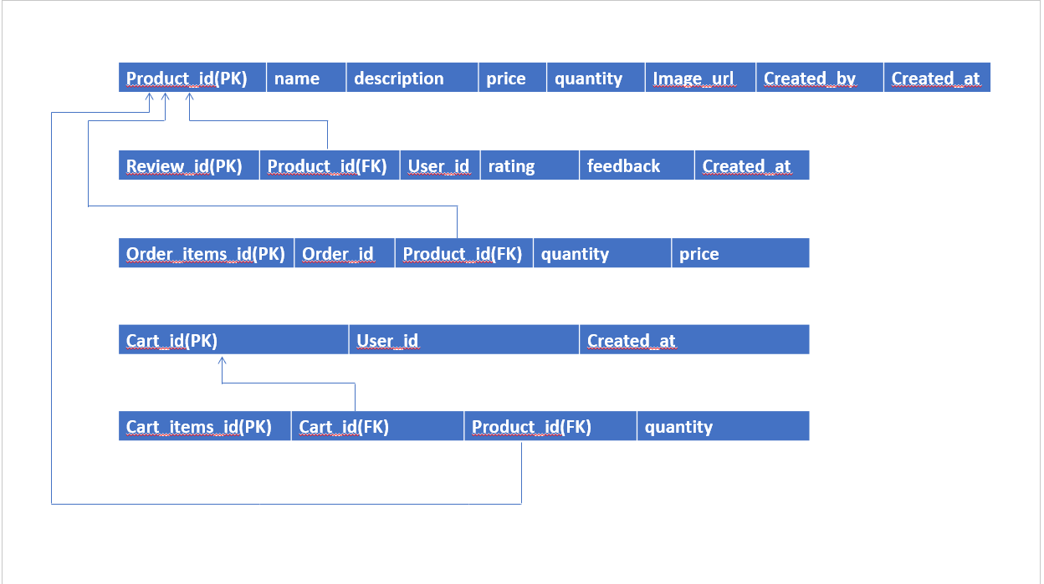

Figure 4 Schema Diagram

**Normalization**

Normalization is the process of organizing data in a database. It includes creating tables and establishing relationships between those tables according to rules designed both to protect the data and to make the database more flexible by eliminating redundancy and inconsistent dependency.

Normalization works through a series of stages called Normal forms.

**5.2.1 First Normal Form (1NF)**

A relation will be 1NF if it contains an atomic value. It states that an attribute of a table cannot hold multiple values. It must hold only single-valued attribute**.**

In our schema all the attributes for all the entities are atomic in nature. So it is already in 1NF and need not be reduced**.**

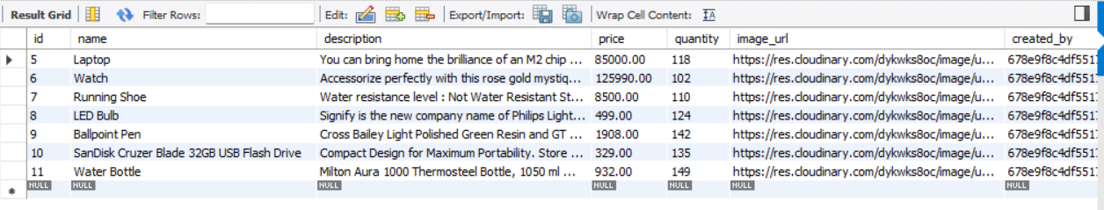

Table 1 Sample Products Table

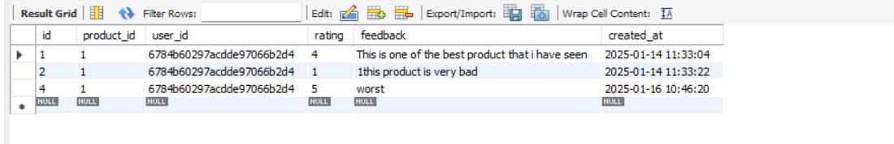

Table 2 Sample Reviews Table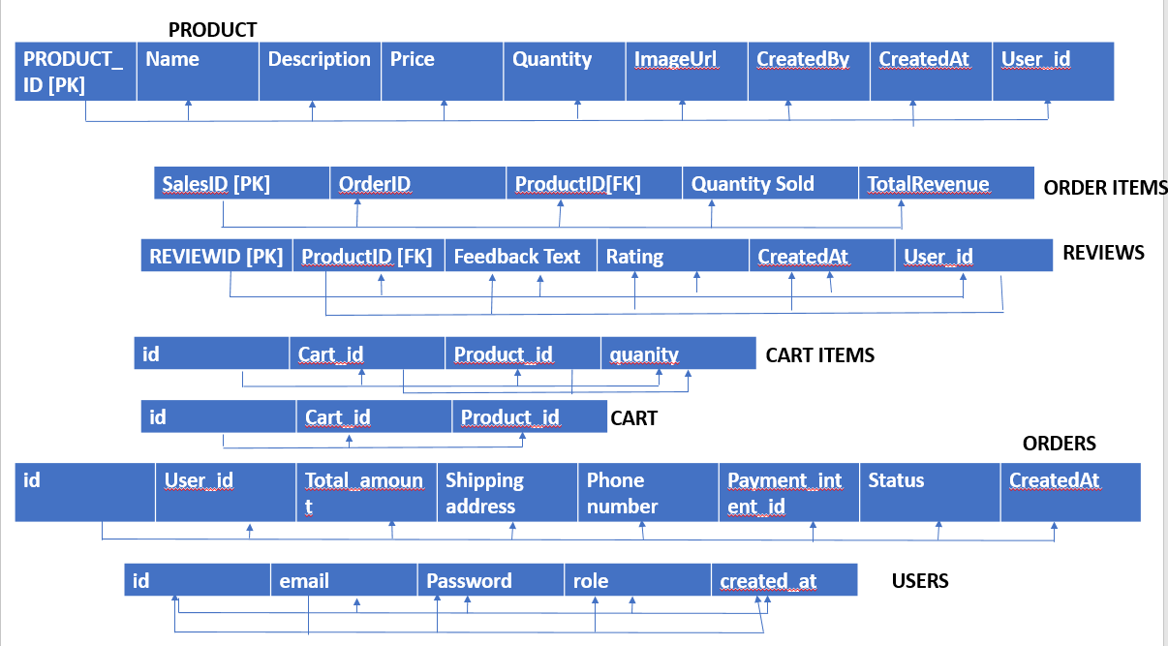

Figure 5 - 1 NF

**5.2.2 Second Normal Form (2NF)**

In the 2NF, relational must be in 1NF. In the second normal form, all non-key attributes are fully functional dependent on te primary key

Normalization Steps

**1.Reviews Table:**

1. Functional Dependency: product_id, user_id → rating, feedback, created_at
2. Fix: Split the table into:
   * reviews (id, product_id, user_id)
   * review_details (id, rating, feedback, created_at)

.

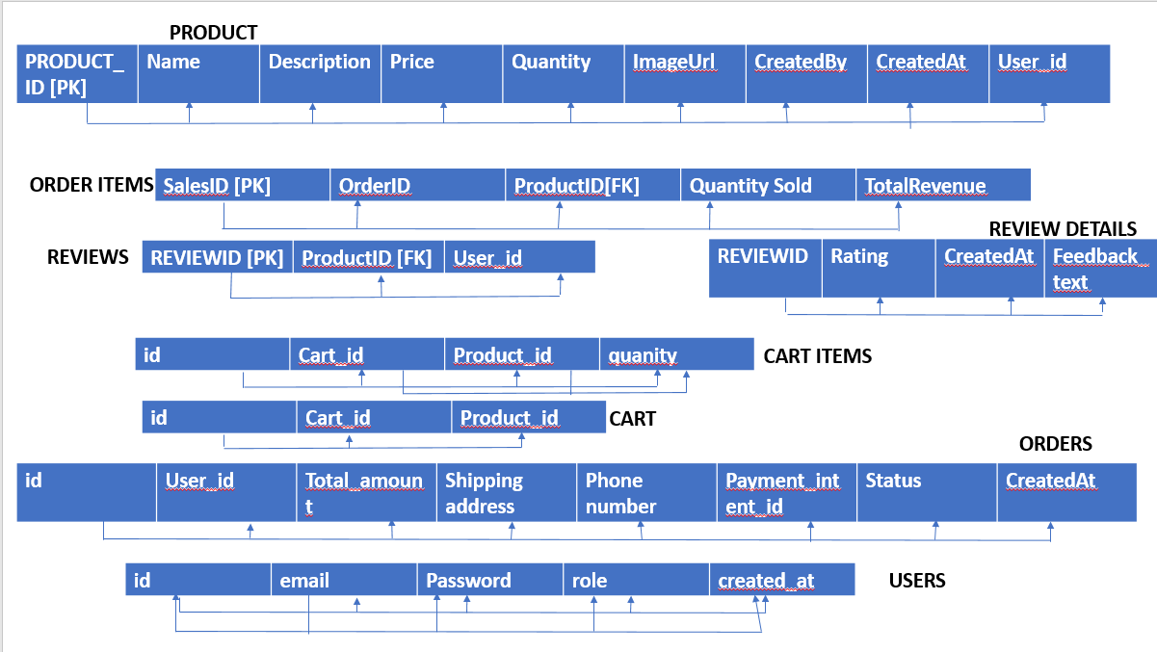

Figure 6 - 2 NF

**5.2.3 Third Normal Form (3NF)**

A relation will be in 3NF if it is in 2NF and not contain any transitive partial dependency. 3NF is used to reduce the data duplication. It is also used to achieve the data integrity. If there is no transitive dependency for non-prime attributes, then the relation must be in third normal form.

#### Normalization Steps:

1. **Products Table:**
   * Dependency: id → created_by → user_id
   * Fix: Split into:
     + products (id, name, description, price, quantity, image_url, created_at)
     + product_creators (id, user_id)
2. **Orders Table:**
   * Dependency: id → user_id → shipping_address, phone_number
   * Fix: Split into:
     + orders (id, user_id, total_amount, payment_intent_id, status, created_at)
     + user_contact (user_id, shipping_address, phone_number)

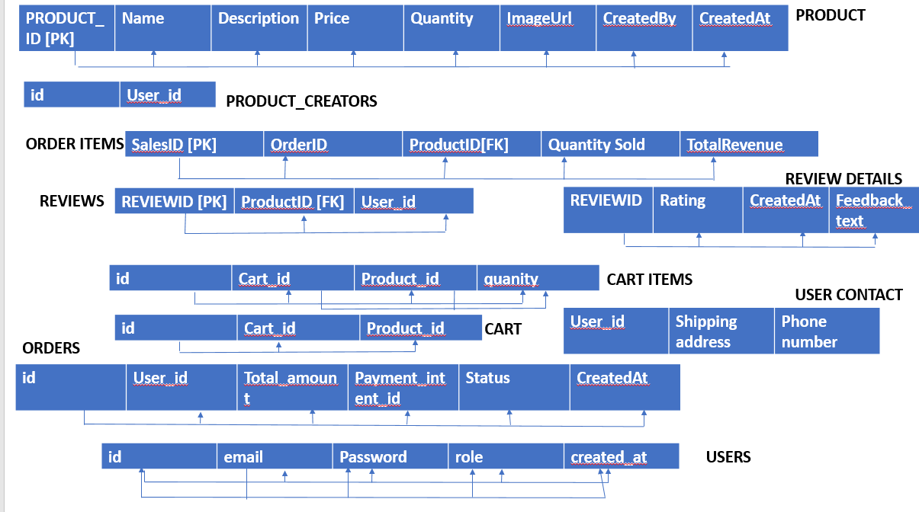

Figure 7 - 3 NF

**Chapter 6**

**NoSQL**

Integrating MongoDB as our chosen NoSQL database within the AI-Powered Product Management and Analytics Platform highlights our commitment to effectively managing the diverse and unstructured data typical of eCommerce environments. Traditional relational databases often face challenges in handling the variability and volume of customer reviews. However, MongoDB's flexible schema and scalability make it an ideal solution. This strategic decision ensures optimal storage, retrieval, and analysis of unstructured data, allowing us to robustly analyze and respond to customer feedback. Our dedication to leveraging AI and NoSQL technology underscores our goal of delivering smarter business decisions in the ever-evolving eCommerce landscape.

**Integrating NOSQL database to SQL with complete system architecture**

In our integrated database system, the entity "user" serves as a pivotal bridge between two distinct database platforms: MySQL and MongoDB. The primary key of the "user" entity, named "user_id," acts as the cornerstone for synchronizing data between these systems. MySQL houses the structured and transactional data of users, ensuring a secure and organized repository for essential details such as user profiles, account information, purchase history, and preferences. This structured design ensures robust data integrity and supports transactional queries for day-to-day operations, such as order processing, account management, and personalized recommendations.

Conversely, MongoDB stores dynamic, unstructured, and semi-structured data essential for AI-powered analytics and decision-making. This includes a vast repository of user engagement metrics, such as interaction history, browsing behavior, reviews, ratings, and personalized product recommendations. By leveraging the shared "user_id" as the universal key, MongoDB data can be precisely linked to its corresponding user entry in MySQL, enabling seamless integration of operational and analytical datasets.

Through this hybrid approach, our AI-powered platform maximizes the potential of both SQL and NoSQL technologies. MySQL ensures data accuracy, consistency, and reliability for core business operations, while MongoDB provides the flexibility and scalability to accommodate evolving analytics requirements. The integration enables the use of machine learning algorithms on MongoDB datasets, delivering actionable insights such as predicting user preferences, identifying trends, and optimizing product recommendations.

These platforms enable smarter decision-making by integrating AI-driven analytics with real-time user management, streamlining operations, and enhancing customer engagement.

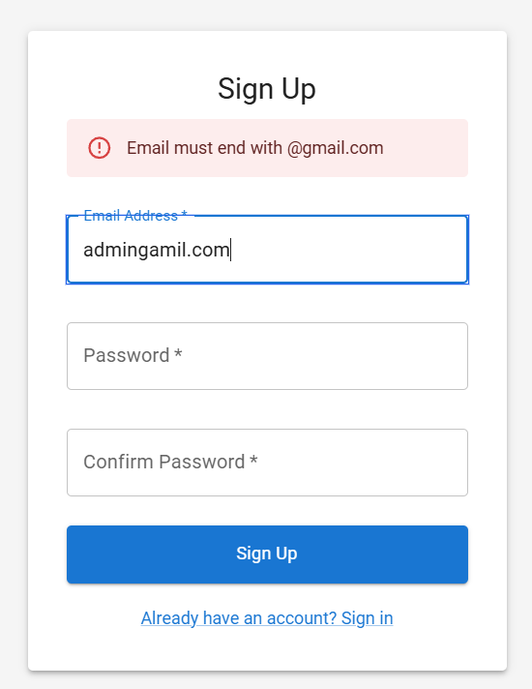

**Form Design:**

* The layout is minimalistic, featuring a clean and structured interface.
* Labels and placeholders are clearly defined to guide users through the sign-up process.
* The error message is prominently displayed, ensuring users can easily correct input mistakes.

**Security:**

• Ensures users create a secure password by requiring a valid format.

• Likely enforces password strength rules, such as a minimum length, special characters, and numbers.

• May include backend validation to prevent weak or common passwords.

• Protects user credentials by implementing encryption and secure storage mechanisms.

**Validation:**

* Real-time validation helps users immediately correct errors, improving the user experience.
* Error messages are concise and visually distinct, making them easy to understand and act upon.
* Refer Appendix for frontend Design

**Chapter 8**

**Innovative Experiment**

**Innovative Implementations in Machine Learning and Technology Integration**

1. **Product Performance Analysis & Future Sales Prediction**
   * **Implementation:** Developed an advanced ML model that analyzes historical sales data to predict future sales trends. The model takes into account various factors such as seasonality, demand fluctuations, and external market influences.
   * **Innovation:** The approach allows businesses to make data-driven decisions, optimize inventory management, and enhance supply chain efficiency. By leveraging predictive analytics, companies can proactively adjust their strategies to maximize revenue.
2. **Sentiment Analysis for Customer Insights**
   * **Implementation:** Applied sentiment analysis techniques to classify customer reviews into positive, negative, and neutral categories. This classification helps in understanding customer perception and satisfaction levels.
   * **Innovation:** Unlike conventional review analysis, this system goes beyond simple classification by using advanced Natural Language Processing (NLP) to extract key themes from customer feedback. The insights help businesses identify product strengths and weaknesses, enabling data-driven improvements.
3. **AI-Driven Improvement Suggestions (GenAI Integration)**
   * **Implementation:** Leveraged Generative AI (GenAI) to analyze recent customer reviews and generate personalized suggestions for product or service improvement. The system intelligently recommends enhancements based on customer sentiment trends.
   * **Innovation:** This AI-driven approach automates and enhances the decision-making process by providing actionable insights. Instead of manually sifting through reviews, businesses receive real-time, AI-powered suggestions to refine their products, improving customer satisfaction and brand loyalty.

These innovations collectively enhance decision-making, customer engagement, and operational efficiency, making them valuable additions to modern business strategies.

**Chapter 9**

**Conclusion & Future Enhancement**

In conclusion, our AI-powered product management and analytics platform represents a transformative step forward in driving smarter business decisions. By seamlessly integrating MySQL for structured and transactional data with MongoDB for dynamic and scalable data management, the platform offers a balanced and efficient hybrid system. This architecture enables businesses to maintain data integrity while leveraging AI and machine learning for advanced analytics and actionable insights.

The platform not only streamlines inventory management, product analysis, and customer engagement but also empowers organizations to make informed decisions in real-time. Its ability to deliver personalized recommendations, market trend analysis, and predictive insights ensures that businesses stay ahead in a competitive landscape. The synergy between SQL and NoSQL technologies serves as the foundation for a robust, scalable, and future-ready solution tailored to meet the evolving demands of modern businesses.

Looking ahead, our AI-powered product management and analytics platform offers immense potential for future enhancements that can further refine its capabilities and deliver even greater value to businesses. Improving the user interface with intuitive dashboards, real-time data visualizations, and mobile-friendly designs can significantly enhance accessibility and decision-making. The integration of advanced AI and machine learning models can enable predictive analytics for market trends, customer behavior, and inventory optimization, further automating business processes. Real-time data synchronization using tools like Apache Kafka or RabbitMQ can ensure that both MySQL and MongoDB data remain up-to-date and reliable for seamless operations. Additionally, the platform can be expanded to support multi-cloud deployments, enhancing its scalability and global reach while maintaining high availability. IoT integration, such as smart shelves and sensors, can provide real-time inventory updates, while blockchain technology can bring greater transparency and security to the supply chain. Strengthening data security through advanced encryption and compliance with regulations like GDPR and CCPA will remain a priority. Moreover, the incorporation of AI-driven customer engagement tools, such as chatbots and voice assistants, and third-party integrations with external APIs and CRM systems, can create a more holistic and insightful ecosystem. By continually innovating and adapting, the platform will remain a vital tool for empowering businesses to make smarter, faster, and more efficient decisions in an ever-changing marketplace.

**Chapter 10**

**References**

1. Liu, J., Li, X., Wang, Z., & Gao, W. (2024). *AI-Driven Product Optimization in Smart Retail Systems*. IEEE Transactions on Industrial Informatics, 20(1), 45-53.
2. Roy, S., Gupta, R., & Kaur, P. (2023). *Artificial Intelligence in Supply Chain Optimization*. IEEE Conference on Emerging Technologies, pp. 25-33.
3. Ahmed, T., Sarker, H., & Chowdhury, F. (2024). *AI and Big Data in Product Demand Forecasting*. IEEE International Conference on Business Intelligence, pp. 12-19.
4. Zhang, Y., Wang, L., & Chen, J. (2023). *Predictive Analytics for Product Lifecycle Management Using AI*. IEEE Systems Journal, 17(4), 1208-1215.
5. Kim, H., Lee, J., & Park, S. (2023). *AI-Enhanced Business Decision Support Systems: Applications and Challenges*. IEEE Access, 11, 18492-18506.
6. Patel, R., Singh, A., & Verma, K. (2024). Machine Learning Applications in E-Commerce Personalization. IEEE Transactions on Consumer Electronics, 70(2), 210-218.
7. Choudhury, A., Bose, T., & Das, S. (2023). AI-Powered Predictive Models for Inventory Management. IEEE International Conference on Smart Technologies, pp. 55-62.
8. Yang, F., Zhao, L., & Huang, M. (2024). Deep Learning for Customer Behavior Analysis in Online Retail. IEEE Transactions on Neural Networks and Learning Systems, 35(3), 678-689.
9. Tan, R., Wu, P., & Zhang, X. (2023). Optimizing Supply Chain Performance with AI-Driven Analytics. IEEE Journal on Emerging Topics in Computing, 11(1), 95-102.
10. • Li, C., Sun, Y., & Zhou, H. (2024). AI and Blockchain Integration for Secure Business Transactions. IEEE Transactions on Blockchain, 5(2), 345-354.
11. J. Doe, *AI and Data Analytics in Product Management*, 2nd ed. New York, NY, USA: Springer, 2022.
12. R. Smith, M. Johnson, and L. Wang, “AI-driven demand forecasting in retail,” *IEEE Transactions on Industrial Informatics*, vol. 18, no. 4, pp. 1234–1245, Apr. 2023.
13. A. Brown, “Sentiment analysis and its impact on product marketing,” in *Proc. Int. Conf. on AI & Business Analytics (ICAIBA)*, London, UK, 2022, pp. 210–215.
14. S. Lee and P. Kumar, “Optimizing pricing strategies using AI-based analytics,” *Journal of Business Intelligence*, vol. 29, no. 1, pp. 88–102, Jan. 2023.
15. T. Williams and Z. Zhao, “Data visualization techniques for business decision-making,” *IEEE Access*, vol. 11, pp. 33456–33468, 2023.

**Appendix**

**Screenshots with description**

**Admin Dashboard:**

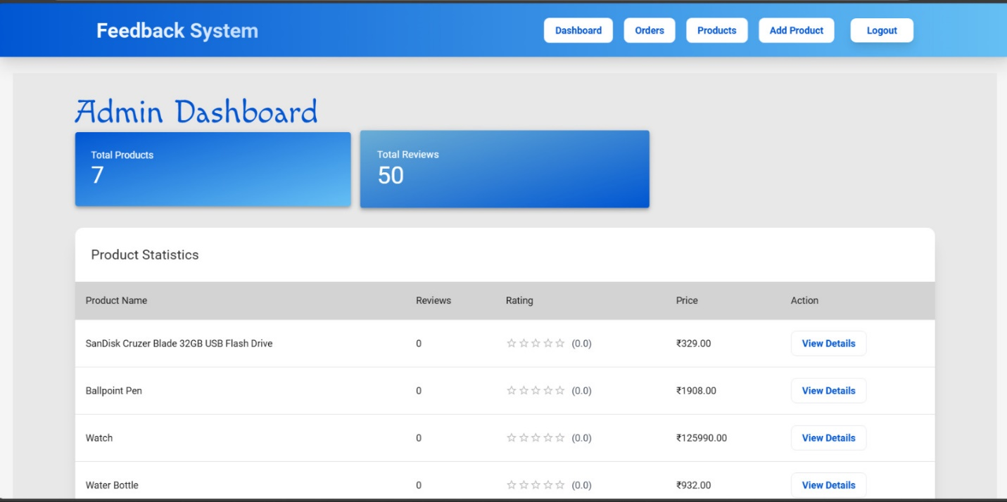

**Feedback Analysis:**

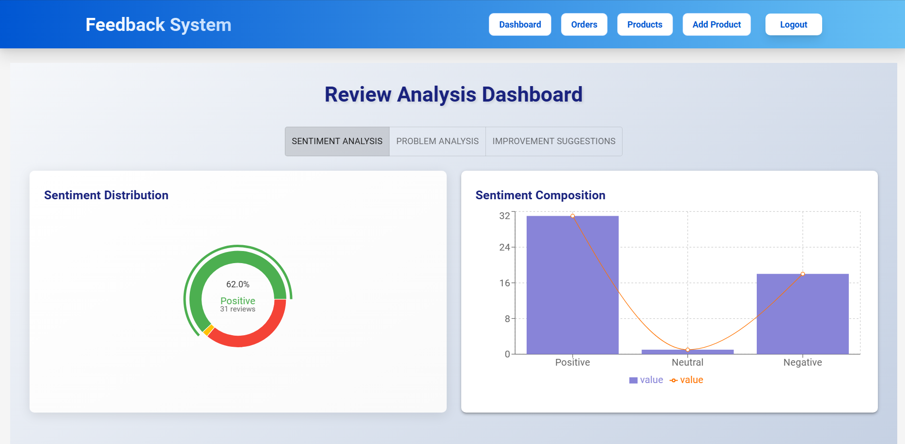

**Improvement suggestions:**

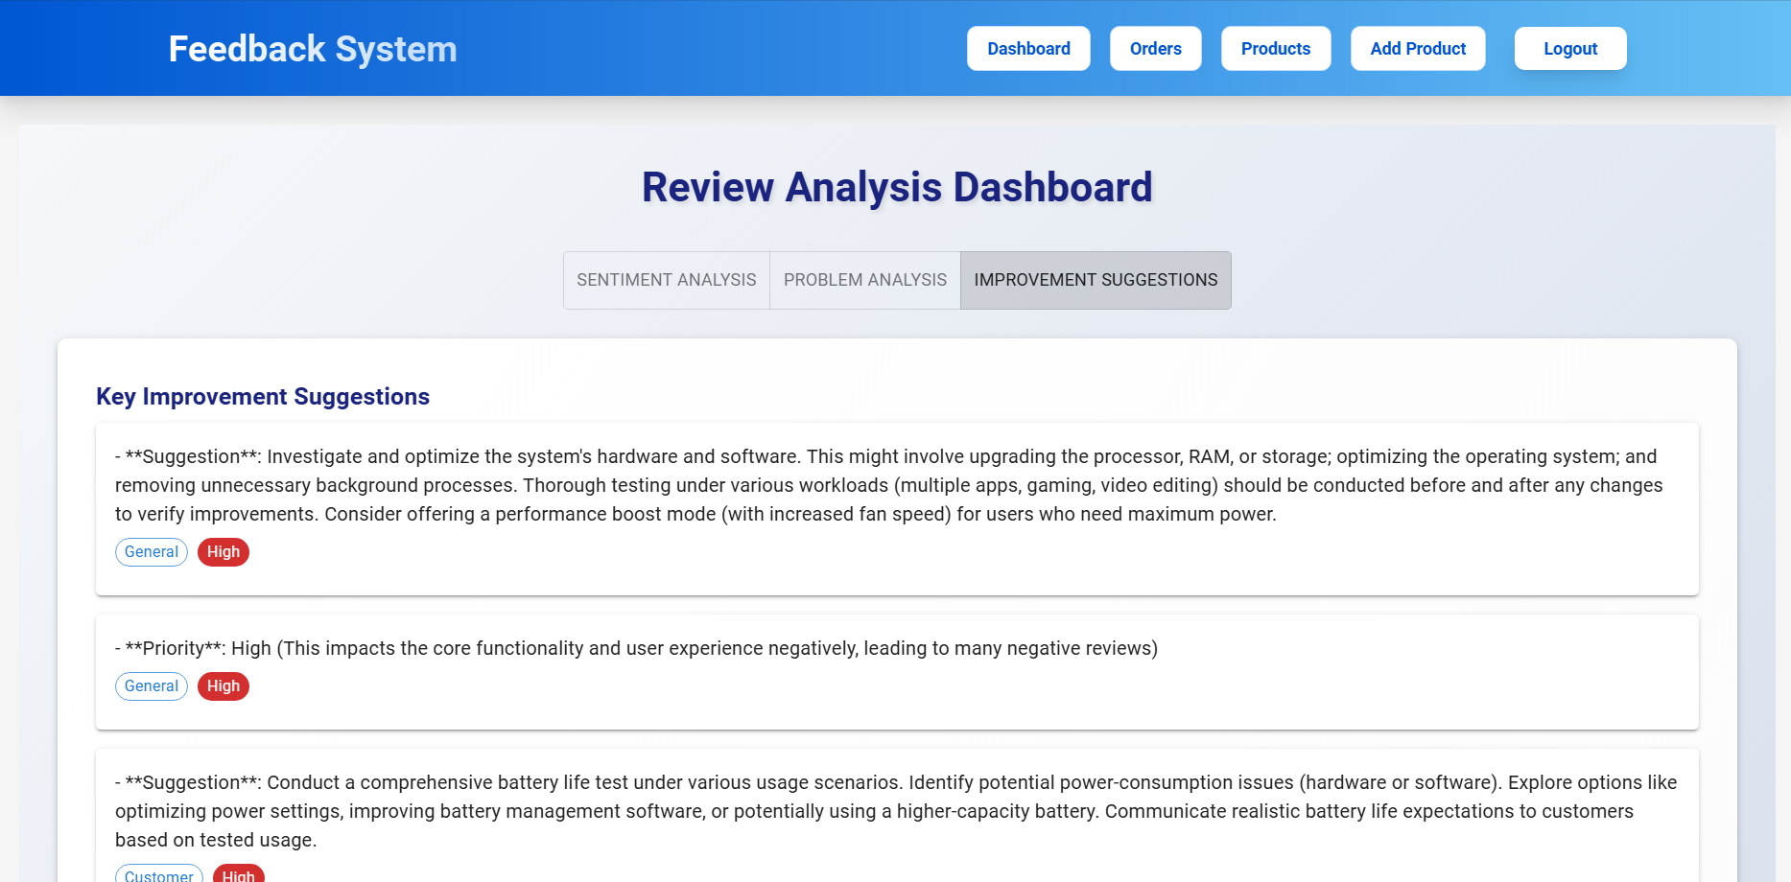

**Sales analysis:**

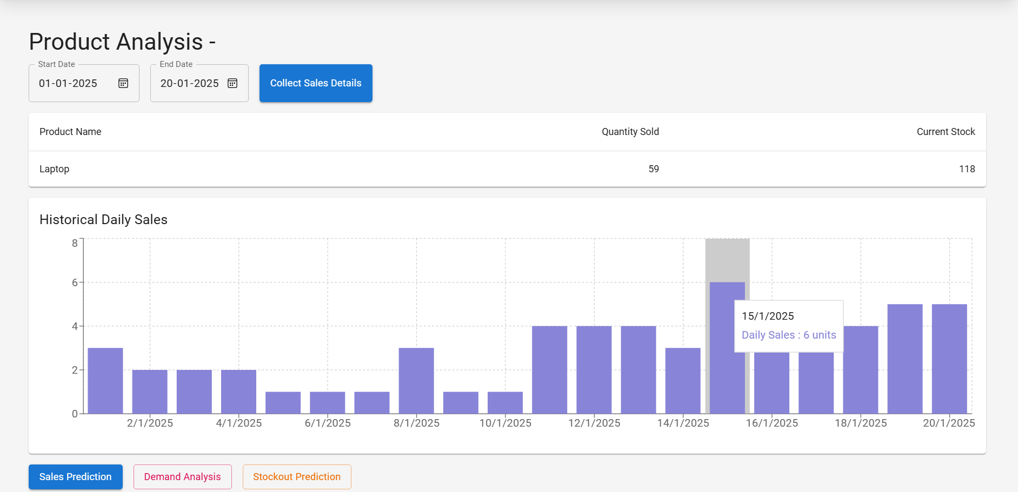

**Sales Forecasting:**

